**User Guide Feedback**

**More Images/Screenshots/Icons with the instructions**

* Might be beneficial to have a list/table/annotated screenshot of the main buttons at the beginning of the tutorial – maybe just the icons and the names, no need for in depth details as that is already included in the appendix. I think it will be helpful for new users to become familiar easily and avoid having to go back and forth between the tutorial instructions and the appendix to understand which button the instructions are talking about.
  + Similarly, many buttons are shown in Figures (such as Figure 8 where the Multiple Evacuation Messages button is highlighted) however as the figures are quite spread out, the user needs to scroll back and forth between the figure and the instructions. It might be better to have smaller images/screenshots with the step they are needed in (e.g the Multiple Evacuation Message button next to 3.53.4 step 8 where it is being used for the first time).
  + Another example is in 3.53.4 step 10: 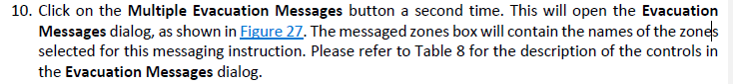  
    the tutorial asks to jump to Figure 27 which is 20 pages away! This will be very inconvenient for the user, as they will need spend a long time scrolling back or searching for which step they are up to!
* Include screenshots when referring to buttons that appear/are not always on screen (such as the outputs button) as they can be difficult to notice on top of the map. Some newly appearing buttons were difficult for me to find even though they were right in front of me on the page
  + **Button design -** Perhaps change the design of these appearing/disappearing buttons slightly to make them stand out more on the page/make their entrance more animated to capture attention.

**Language/Wording of the Tutorial**

Edit Layers Button

It may be better to change the name of the “Edit Layers” button and make it more broad/general. As this button is used to complete a multitude of tasks, a broader name could help the user to understand that the menu is dynamic and that its content changes.

Scenario Settings

*Tutorial Text:*

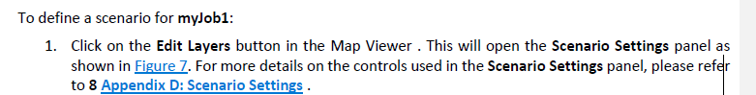

*EES:*

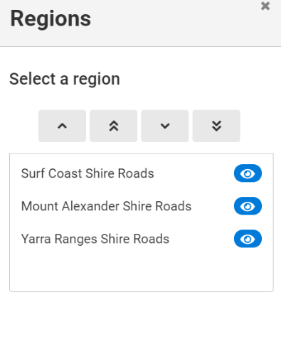

These instructions are a little bit confusing as the panel that opens is “Regions”. If the reader does not read ahead to the next steps/view figure 7, they may be confused and think that they have opened the wrong section. Might be better to change the wording to “This will open the Select a region panel” or similar. Just to make it clearer.

**Other Issues**

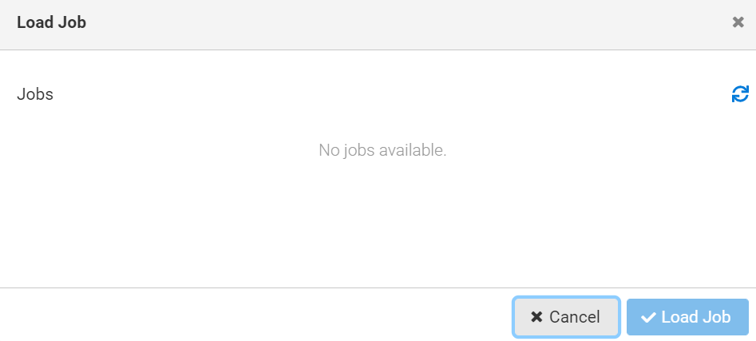

No jobs available – even after creating new jobs. It’s also a bit tricky to continue following the tutorial after 3.6 because the sample jobs are not available.